ADVANCED DAX AND MEASURES DEVELOPMENT
Week 3 Internship Task

Project: Sales Performance Analysis Dashboard using Microsoft Power BI

Submitted by: SONU KUMAR SHAW
Internship: Virtual Power BI Data Visualization Intern
STREAM: BBA
COLLAGE: B.P.Poddar Institute of Management and Technology

Task Week 3

- Introduction to DAX

DAX (Data Analysis Expressions) is the formula language used in Power BI for creating calculated measures, calculated columns, and analytical expressions. In this project, DAX is used to convert the cleaned financial data model into meaningful business indicators. Measures are evaluated dynamically according to the filters and selections made by a user in a Power BI report. This makes DAX important for interactive dashboards because the same measure can produce different results for different countries, products, segments, years, or other filter contexts.

For the Sales Performance Analysis Dashboard, the focus is on sales, profit, profitability, and year-over-year performance. The measures are designed to be simple, reusable, and suitable for cards, charts, tables, and KPI visuals.

- Project Data and Business Context

The project uses the Microsoft Financial Sample dataset as a publicly available reference dataset. The data contains fields such as Date, Segment, Country, Product, Units Sold, Sale Price, Gross Sales, Discounts, Sales, COGS, and Profit. The Week2 data model organizes the business data into a fact table and supporting dimension tables. The DAX measures in this task are intended to work on that model and support the final dashboard.

Business Area | Example Fields | Purpose
Sales | Sales , Gross Sales , Discounts | Measure revenue performance
Profit | Profit , COGS | Measure business profitability
Product | Product , Units Sold | Compare product performance
Geography | Country | Compare markets
Time | Date , Year , Month | Trend and period analysis
Segment | Segment | Compare customer/business segments

- Business Metrics and KPIs Selected

The following KPIs are selected because they directly describe the financial performance of the dashboard and can be interpreted by business users without complex calculations.
KPI | Meaning | Business Use
Total Sales | Total revenue generated in the selected filter context. | Main revenue KPI.
Total Profit | Total profit generated after the relevant costs. | Profitability KPI.
Profit Margin | Profit as a percentage of sales. | Shows how efficiently sales are converted into profit.
Total Units Sold | Total quantity sold. | Shows sales volume.
Average Selling Price | Average sales value per unit sold. | Helps compare pricing and volume.
Sales YoY Growth | Percentage change in sales compared with the previous year. | Shows growth or decline over time.

- DAX Measures and Formulas

Create these as measures in Power BI using the New measure option. The table name used below is Financials, matching the Microsoft Financial Sample structure. If the Week 2 model uses a different fact table name, replace Financials with the actual table name while keeping the calculation logic unchanged.

- Total Sales
Total Sales = SUM(Financials[Sales])

Rationale: Adds the Sales column. Because it is a measure, the value automatically changes when users filter the report by year, country, product, or segment.

- Total Profit
Total Profit = SUM(Financials[Profit])

Rationale: Calculates total profit in the current filter context. It can be displayed in KPI cards and used in profitability charts.

- Profit Margin
ProfitMargin = DIVIDE([TotalProfit],[TotalSales],0)

Rationale: Calculates profit as a percentage of sales. DIVIDE is used to avoid an error if sales are zero.

- Total Units Sold
Total Units Sold = SUM(Financials[UnitsSold])

Rationale: Shows the total sales volume and can be used to compare products or segments.

- Average Selling Price
Average Seling Price = DIVIDE([TotalSales],[TotalUnitsSold],0)

Rationale: Calculates the average sales value per unit. It supports pricing and volume analysis.

- Previous Year Sales
Previous Year Sales= CALCULATE( [TotalSales], DATEADD(DimDate[Date],-1,YEAR) )

Rationale: Returns sales for the previous year when a proper DimDate table is related to the fact table.

- Sales YoY Growth%
Sales YoY Growth% = DIVIDE( [Total Sales]-[Previous Year Sales], [Previous Year Sales],) 0

Rationale: Measures year-over-year sales growth. Positive values indicate growth; negative values indicate decline. 5. Date Table and Time Intelligence.

- Date Table and Time Intelligence

Time-intelligence measures such as Previous Year Sales require a continuous date table. The recommended Dim Date table should contain one row for each date and fields such as Date, Year, Month Number, Month Name, and Quarter .The Date field in Dim Date should be related to the corresponding date field in the Financials fact table. This structure makes year-over-year and other period comparisons more reliable.
Example DimDate
DAX: DimDate= ADDCOLUMNS( CALENDAR(MIN(Financials[Date]),MAX(Financials[Date])),
"Year" , YEAR([Date]),
"Month Number", MONTH ([Date]),
"Month Name", FORMAT ([Date],"MMMM"),
"Quarter" , "Q"&FORMAT([Date],"Q") )

- Calculation Logic and Interrelationship

The measures are connected logically. Total Sales and Total Profit are base measures. Profit Margin uses both of these measures. Previous Year Sales uses Total Sales together with the DimDate filter context. Sales YoY Growth then compares current sales with previous-year sales.
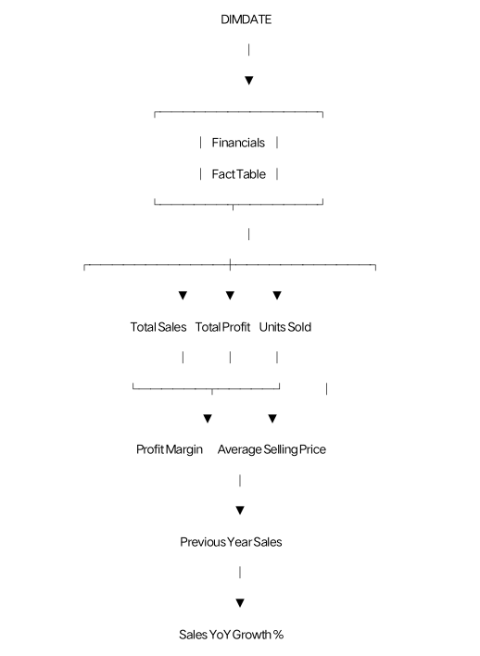
- How the Measures Can Be Applied in Power BI

Visual | Application
KPI Cards | Total Sales, Total Profit, Profit Margin and Total Units Sold can be placed in cards at the top of the dashboard.
Line Chart | Sales by Date/Year can show trends, while Sales YoY Growth% can provide a growth perspective.
Bar Chart | Total Sales or Total Profit can be compared across Product, Country, or Segment.
Matrix | Product and Country can be placed in rows with Total Sales, Total Profit and Profit Margin as values.
Slicers | Year, Country, Product and Segment slicers can dynamically change al measures.
Tooltip | Profit Margin and YoY Growth can be added as tooltip measures to give more context to charts.

- Example Business Interpretation

Suppose the dashboard is filtered to a particular country and year. Total Sales shows the revenue generated under that filter. Total Profit shows the resulting profit, while Profit Margin explains the profitability relative to sales. If Sales YoY Growth is positive, the selected period has higher sales than the comparable previous year. If it is negative, sales are lower than the previous year. These measures allow a user to move from a simple revenue number to a more complete view of business performance.

- Performance and Optimization Considerations

● Prefer measures over unnecessary calculated columns when the calculation needs to respond dynamically to report filters.
● Use a star-schema data model with clear relationships between fact and dimension tables.
● Use a dedicated date table for time intelligence rather than relying on incomplete date fields.
● Use DIVIDE instead of direct division when a denominator can be zero or blank.
● Keep measures focused and reusable ; build more complex KPIs from base measures where practical.
● Avoid unnecessarily expensive iterator functions over very large tables when a simple aggregation can produce the required result.
● Remove unused columns and unnecessary high-cardinality fields from the model to reduce model size and improve report performance.
● Test measure sunder different slicer selections and verify results against known totals.
10. Validation and Testing Plan

Test | Expected Check | Action if Incorrect
Total Sales | Matches the source dataset total for the same filters. | Check Sales data type, blanks, duplicates and filters.
Total Profit | Matches source Profit total. | Check Profit field and aggregation.
Profit Margin | Equals Total Profit ÷ Total Sales. | Check measure references and formatting.
Previous Year Sales | Changes correctly when year filter changes. | Check DimDate relationship and continuous dates.
YoY Growth | Matches the percentage change from previous year | Check Previous Year Sales and zero/blank handling.
Slicers | Al KPIs respond to relevant filters. | Check relationships and filter direction.

- Expected Impact on Data Interpretation

The DAX measures make the dashboard more informative because they convert raw financial fields into business-level indicators. Instead of only showing individual sales transactions or raw columns, the report can explain revenue, profitability, volume, pricing, and growth. Dynamic measures also a low users to investigate the same KPIs at different levels, such as total business, country, product, segment, or year. This supports faster comparison and more consistent decision-making based on the same calculation definitions.

- Challenges and Risk Mitigation

Challenge | Potential Effect | Mitigation
Incorrect relationships | Can produce wrong totals or and time-intelligence results. | Use a clear star schema. Verify relationships.
Missing or duplicate dates | Can break time-based calculations. | Use a continuous DimDate table and validate dates.
Division by zero | Can create errors in ratio measures. | Use DIVIDE with an alternate result.
Wrong data types | Can affect aggregation and calculations. | Set numeric, date, and text data types correctly.
Performance issues | Complex formulas can become slow on large models. | Use simple reusable measures and optimize the model.
Unverified formulas | A syntactically valid measure can still be logically wrong. | Compare outputs with manually calculated sample values.

- Suggested Dashboard Layout

● Top row : Total Sales | Total Profit | Profit Margin | Sales YoY Growth%
● Second row : Sales trend by Year/Month and Profit trend by Year/Month.
● Third row : Sales by Country and Sales by Product.
● Side or top slicers: Year, Country, Product and Segment.
● Detailed section : Matrix containing Product/Country with Sales, Profit, Margin and Units Sold.
● Tooltips: Add Profit Margin, Total Profit and YoY Growth to improve interpretation of charts.

- Overall Workflow

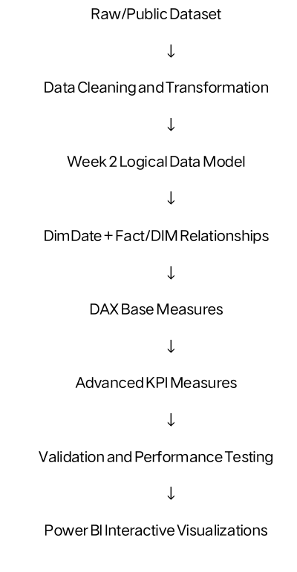

- Conclusion

This Week 3 task demonstrates how DAX measures can turn a structured Power BI data model into useful business intelligence. The selected measures cover revenue, profit, margin, sales volume, average selling price, and year-over-year growth. By using a dedicated date table and reusable measures, the dashboard can respond dynamically to user selections and provide consistent calculations across different visualizations. The approach also considers validation, performance, and practical business interpretation. These measures provide a foundation for building a professional Sales Performance Analysis Dashboard in the later stages of the internship.

